**★ College Management System ★**

# **Team Members**

* **Belal Hassan ( Micro )**
* **Ahmed Essam Kamal**
* **Abdulrahman Mohammed**
* **Mohammed Ali Mohammed**
* **Mohammed Mostafa Mohammed**
* **Mostafa Ahmed Kamal**

# **Project Description**

**🎓 The College Management System is a comprehensive desktop application designed to streamline and manage the day-to-day operations of a college environment. Built with role-based access, the system ensures that students, doctors (instructors), staff, and managers can efficiently perform their respective tasks through personalized dashboards.**

**🔐 Login Panel**

**Secure authentication system that directs users to their respective dashboards based on their role: Student, Doctor, Staff, or Manager.**

**👨‍🎓 Student Dashboard**

**Empowers students to:**

* **Display Personal Data: View and verify their personal profile and academic information.**
* **View Your Courses: Access a list of enrolled courses with relevant details.**
* **View Student Grades: Check grades and academic performance in real-time.**

**🧑‍⚕️ Doctor Dashboard**

**Designed for teaching staff to:**

* **Display Doctor Data: Access and manage their own profile.**
* **View Student List: Browse the list of students associated with their courses.**

**🧑‍💼 Staff Dashboard**

**Provides administrative staff with tools to manage academic operations.**

* **Create New Course: Add new courses to the curriculum.**
* **Register New Doctor: Enroll new doctors into the system.**
* **View Doctor List: Access a list of all registered doctors.**
* **View Students List: Browse all student profiles.**
* **Register New Student: Add new students to the system.**

**👨‍💼 Manager Dashboard**

**Gives upper management a high-level view and control:**

* **View All Staff: Access a complete list of college staff members.**
* **Register New Staff: Add new administrative staff to the system.**

# **How to run the Project**

**Upon startup, the application will display a login screen where you are required to enter a username and password. Depending on your credentials, the system will automatically identify your role. If the credentials belong to a student, doctor, staff member, or manager, the application will navigate to the corresponding dashboard tailored for that user type. Each dashboard provides access to role-specific operations and features, allowing users to perform tasks relevant to their responsibilities within the college system.**

# **UML Class Diagram**

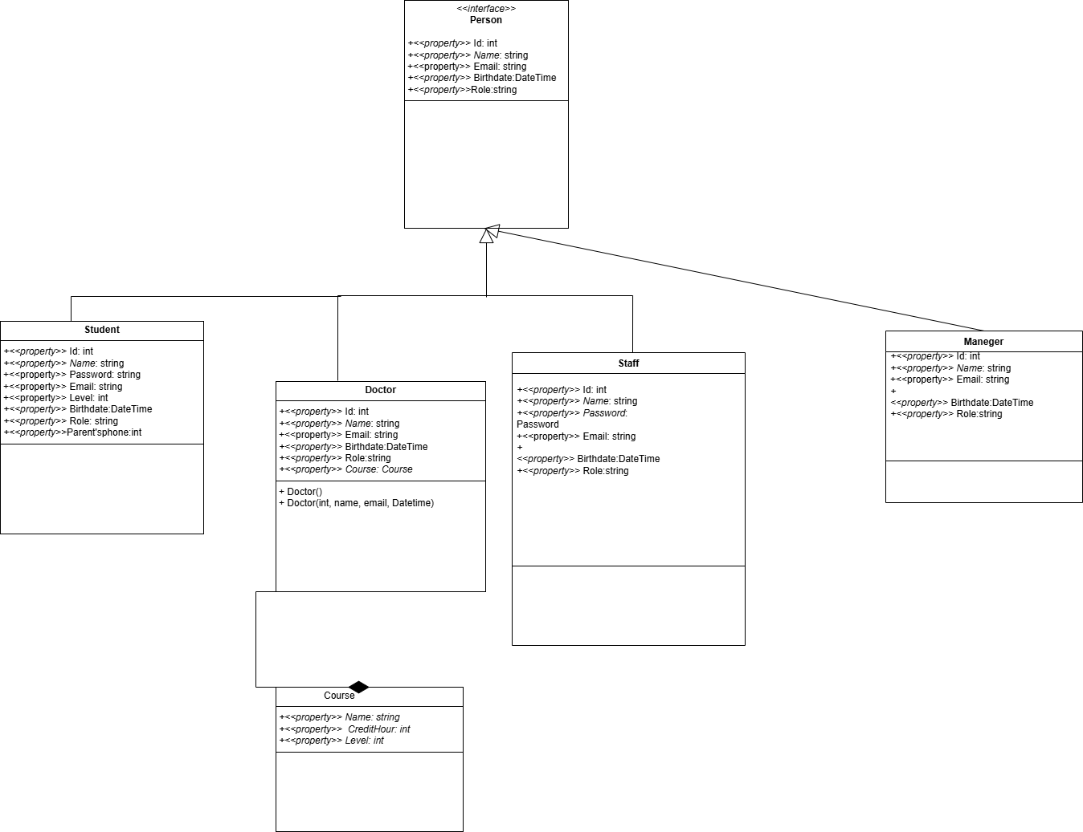

# **Project Code**

